**Task 3**

**Task description**: Create a storage account in any cloud AWS/Azure and try securing it.

(I did this task in AWS management console.)

Log in to the AWS management console and navigate to S3 Services.

.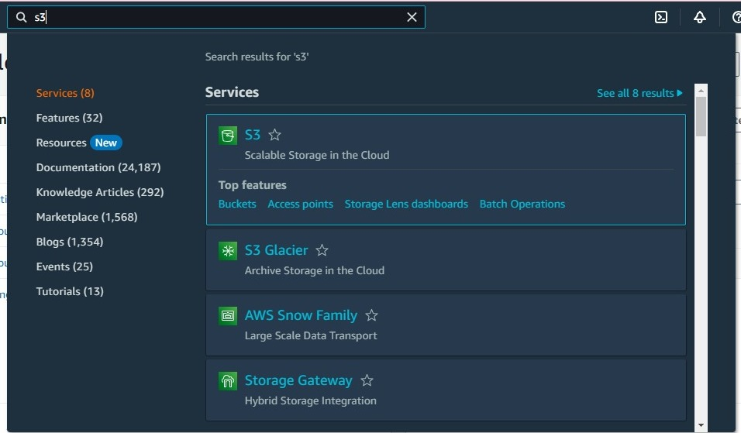

Click on “create bucket”. Choose a unique bucket name, select region.

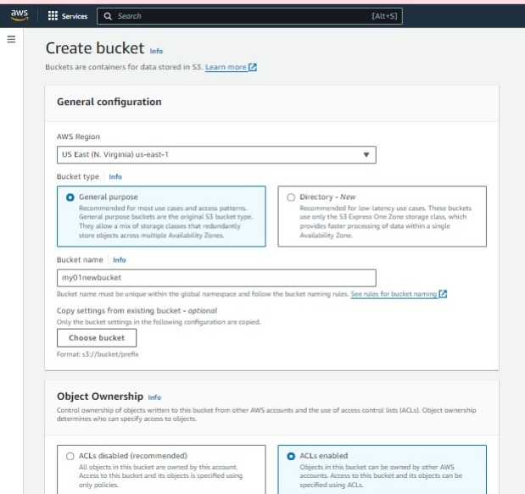

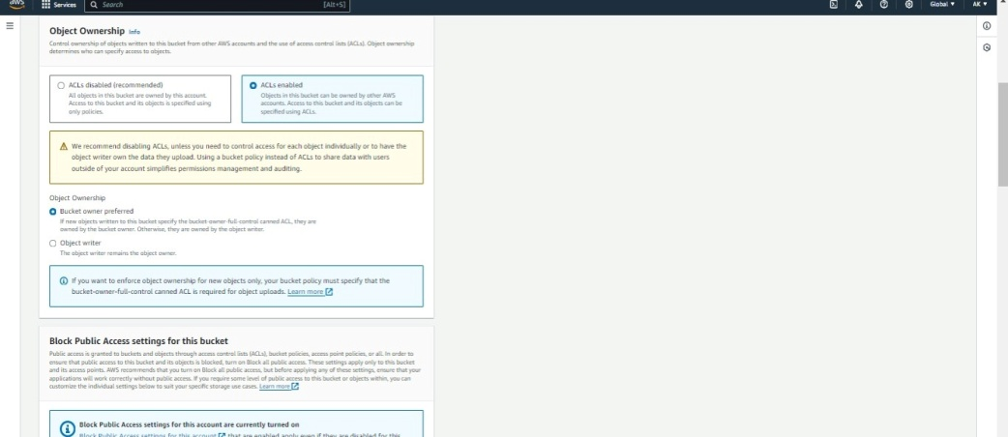

Bucket versioning.

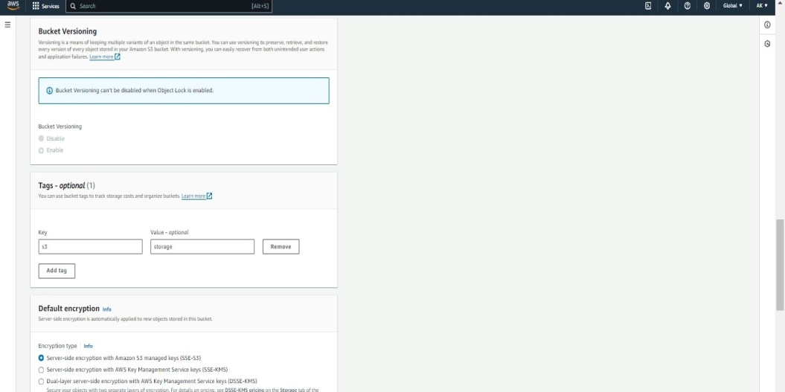

Click on “Create bucket“.

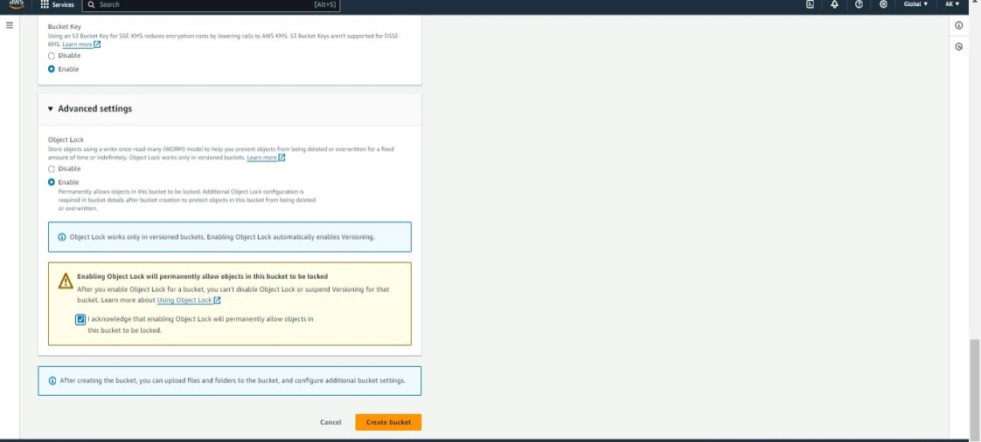

Upload your file.

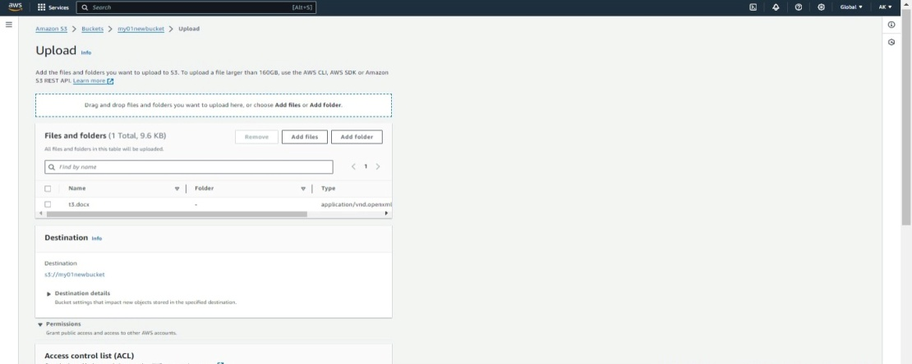

Edit bucket policy.

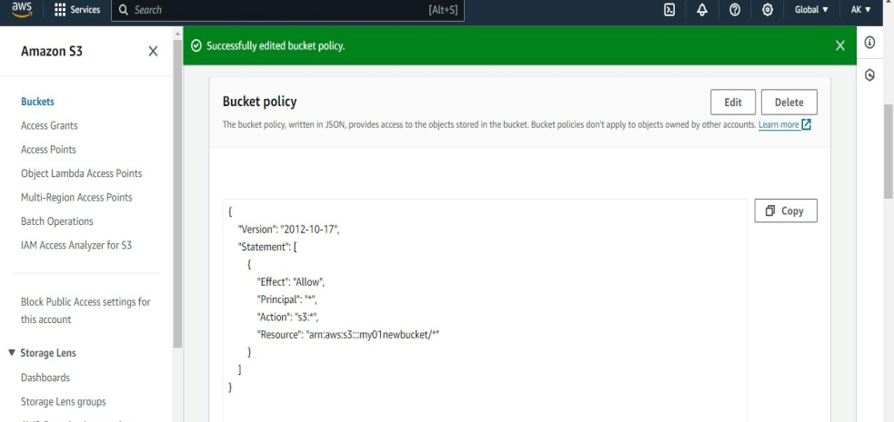

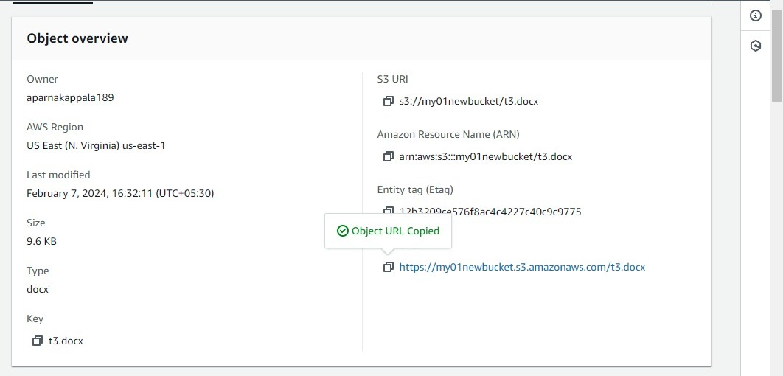

Block off public access.

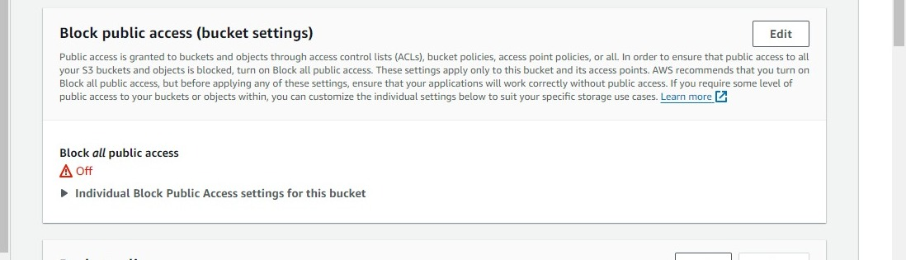

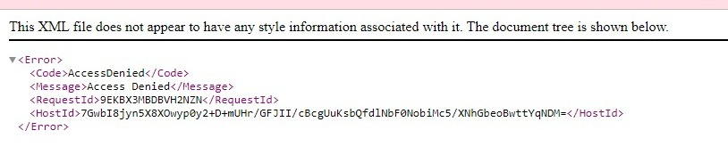

Block all public access. Copy paste the url. (<https://my01newbucket.s3.amazonaws.com/t3.docx>)

Then my file is downloaded.

